# CDBM280 Assignment 1

Given: September 19th, 2022

Due: September 25th, 11:59 PM. No late submissions will be accepted. Submit to the course drop box.

## Part 1 - Create an ERD [35 marks]

Create an ERD for the following scenario:

1. The system to be modeled is a registry of animals.
   1. An animal has a date of birth, a name, and a fancy name. Each animal is assigned a unique tag with an id number that is used by the registry to identify that animal record. Each animal in the registry has a record of their sire and dam (these are their parent animals, meaning they are both other animal records in the registry).
      1. Animals belong to owners, though an animal may not have an owner listed if no one has owned them yet. An animal may, over the course of life, belong to several different owners – each ownership record has an ownership date.
      2. An animal belongs to a breed
      3. An animal is bred by a breeder (a breeder is not considered an owner)
   2. An owner has a name, one address, and one contact phone number.
   3. A breeder has a name, one address, and one contact phone number.
   4. A breed is a subset of a species. A breed has a name, developed year, and the region it was developed in (Think “German Shepherd” for example). A species has a common name (“Dog”, “Cat”) and a scientific name (“Canis Lupus Familiaris”, “Felis Catus”).
2. **Create a List of the questions and assumptions that you’ve made for the above problem. For instance, modalities not explicitly laid out in the problem definition should have an associated assumption and a *brief* explanation.**
3. For Animal table, every animal has one sire and one dam. Sire and dam are also animals. So, Animal table will reference itself.
4. According to instructions, one Animal can have multiple owners. Likewise, one owner can have multiple pet animals. So, there is ‘**many to many’** relationship between Animal and owner entity. In order to, deal with this relationship. AnimalOwnerXREF entity is created. Modality for this relation is “0”. Because, Animal may have an owner or not. Likewise, owner may have any pet or not.
5. Breeder and breed entities have a “**one to many**” relationship. Because breeder may have bred many types of animals during his life. Also, modality is “0”. Because many breeders may have not bred any animal.
6. There can be several animals of same breed. That’s why, animal and breed entities have a relation of **one to many**.

## Part 2 Convert ERD to Relational Schema (15 marks)

Convert the ERD below into a relational schema. Provide a final schema. An ERD drawing is not your final solution to this part.

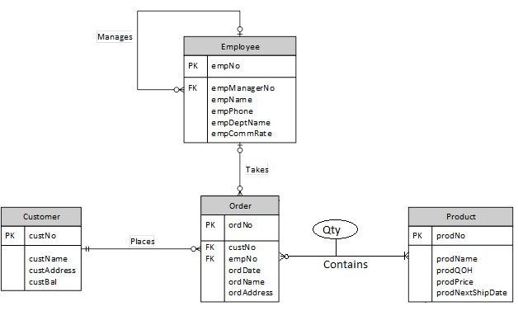

Submission Instructions:

Submit a copy of your work to the CDBM280 Brightspace drop box. Name your document lastname.docx

#### **Firstly, Ensure the diagram is normalized:**

#### **For each weak entity** (weak entity to strong entity).

* The only weak entity here is Order. However, Order entity is connected to customer (fk: custNo) and employee(fk: empNo).

#### **For a many-to-many relationship (N:M)**

* Order and Product entities have many to many relationships.

(In one order, there are many products. Also, many orders have the same product. So, there is many to many relationship).

* + Creating new “OrderProductXREF” entity to solve this many to many relationships.

#### **Review and Consolidate**

* Adding ‘quantity’ field in “OrderProductXREF”.

#### **For each entity (Entities to Relations):**

* Employee (**empNo,** employeeManagerNo(fk), empName, empPhone, empDeptName, empCommRate)
* Order (**ordNo**, custNo(fk), empNo(fk), ordDate, ordName, ordAdress)
* Customer (**custNo,** custName, custAddress, custBal)
* Product (**prodNo,** prodName, prodQOH, prodPrice, prodNextShipDate)

#### **For each relationship (Relationships to Relations)**

* “places” is 1:M relationship
  + Order (**ordNo**, custNo(fk), empNo(fk), ordDate, ordName, ordAdress)
  + Constraint:
    - Order(custNo(fk)) references customer(**custNo**).
* “takes” is 1:M relationship
  + Order (**ordNo**, custNo(fk), empNo(fk), ordDate, ordName, ordAdress)
  + Constraint:
    - Order(empNo(fk)) references employee(**empNo**).
* “contains” is M:N relationship
  + OrderProductXREF(**ordNo(fk), prodNo(fk),** quantity).
  + Constraint:
    - OrderProductXREF(**ordNo(fk)**) references Order(**ordNo**).
    - OrderProductXREF(**prodNo(fk)**) references Product **(prodNo).**
* **“**manages**”**  is 1:M relationship
  + Employee (**empNo,** employeeManagerNo(fk), empName, empPhone, empDeptName, empCommRate)
  + Constraint:
    - Employee(employeeManagerNo(fk)) references Employee(empNo).

*Note:- here, “employeeManagerNo” is a “empNo” of manager.

#### **Final Schema**

* Employee (**empNo,** employeeManagerNo(fk), empName, empPhone, empDeptName, empCommRate)
  1. Employee(employeeManagerNo(fk)) references Employee(empNo).
* Order (**ordNo**, custNo(fk), empNo(fk), ordDate, ordName, ordAdress)
  1. Order(custNo(fk)) references customer(**custNo**)
  2. Order(empNo(fk)) references employee(**empNo**).
* Customer (**custNo,** custName, custAddress, custBal)
* Product (**prodNo,** prodName, prodQOH, prodPrice, prodNextShipDate)
* OrderProductXREF(**ordNo(fk), prodNo(fk),** quantity)
  1. OrderProductXREF(**ordNo(fk)**) references Order(**ordNo**).
  2. OrderProductXREF(**prodNo(fk)**) references Product **(prodNo).**